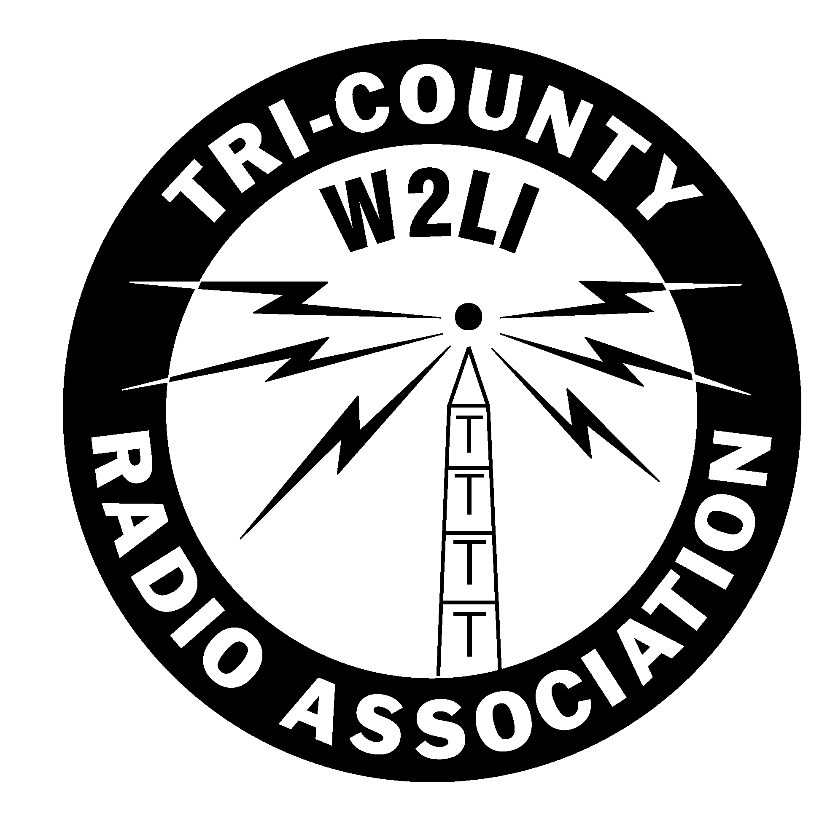
Date of Application
Month Day Year
| | | |
Tri-County Radio Association, Inc.
Application for Membership

Submit this application, along with payment of the required dues at a regular meeting of the Tri-County Radio Association. Dues are $30 annually and are pro-rated in the third and fourth quarter. Members joining in December will be required to pay the following year’s dues. Dues must be paid in full at time the membership application is presented. Dues for additional family members in the same household or a student enrolled full time in an accredited educational institution are ½ regular dues.

PLEASE PRINT ALL INFORMATION CLEARLY

Application Type [ ]Regular Member (holder of current license) [ ]Associate Member (unlicensed)

Do you wish to opt out of having your phone & email printed on the club roster? [ ] YES
Only your name and call sign will be published.

APPLICANT NAME: ___________________________________________________________________

Home Address ______________________________________________________________________________________
Street City ST ZIP

Home Phone ________________________________ Cell Phone ______________________________

Email ______________________________________________________________

Applicant Call Sign ___________________________ [ ] Pending (include copy of Successful Completion of Exam certificate)

License Expiration ___________ Date First Licensed ___________ Ever been denied a license [ ] Yes [ ] No

License Class [ ] Technician [ ] General ARRL Member [ ] Yes [ ] No
[ ] Extra [ ] Novice [ ] Advanced ID number ___________________

Are you a member of: ___ ARES ___ RACES ____ Skywarn ____CERT or OEM if yes, municipality ______________

Type of Equipment and bands / modes operated__________________________________________________________

_________________________________________________________________________________________________

Other Hobbies _____________________________________________________________________________________

_________________________________________________________________________________________________

I hereby apply for membership in the Tri-County Radio Association, Inc. and agree to abide by the constitution, by-laws and other rules of the Association. Sponsorship is recommended but not required.

Applicant Signature Sponsor’s Name Sponsor’s Signature

TCRA USE ONLY | Accepted as member  [ ]YES [ ]NO | Date Accepted as member | Dues Received $_____________
Rev 2-7-18

